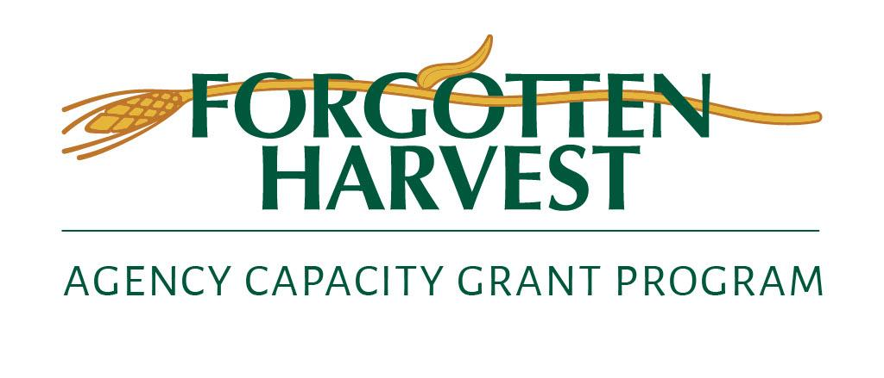

**FOR IMMEDIATE RELEASE**

**Contacts:** Christopher Ivey, Forgotten Harvest

[civey@forgottenharvest.org](mailto:civey@forgottenharvest.org), 248-298-3416

Carolyn Artman, MCCI – on behalf of Forgotten Harvest

[cartman@mccicorp.com](mailto:cartman@mccicorp.com), 313-269-4729

**Forgotten Harvest announces round two of the $5 million Agency Capacity Grant Program to help its metro Detroit nonprofit partners reduce food insecurity.   
*The innovative three-year initiative leverages MacKenzie Scott donation.***

**OAK PARK, Mich., June 13, 2023** – Today Forgotten Harvest announced its second round of Agency Capacity Grants, awarding a total of $644,528 to eighteen partner agencies that distribute food in Metro Detroit. The grant program recognizes the essential role of its partner agencies to deliver food where it is most needed throughout Metro Detroit. The program has granted a total of 1.25 million dollars in the first two rounds of grants. The grant awards are divided into three groups Innovate, Maintain and Expand. Round 3 proposals are due this summer with final decisions will be made in the Fall.

1. **Hartford Memorial Baptist Church – Wayne County**

Grade and asphalt 80% of their staging lot, which is used by Project Healthy Community as well as Hartford Memorial. Eliminate potholes and improve client flow and the safety with gates and directional markings. This will increase the number of cars and people served by 25%.

1. **Yad Ezra - Oakland County**

Specializing in Kosher food and serving people who are Ukrainian, former Soviets and Jewish, Yad Ezra will expand their vegetable garden and add fruit trees to provide culturally-specific fruit and vegetables for their clients.

1. **Fish & Loaves Community Food Pantry - Wayne County**

The grant expands cooler and freezer capacity and will enable the pantry to serve 30% more clients.

1. **Renaissance Vineyard Church Food Pantry – Oakland County**

Upgrade electrical in their 100-year-old building, replace two exterior doors for greater safety, purchases small carts to make client choice shopping easier, replace the restaurant size coffee maker for warming center clients and volunteers, and repair part of the parking lot.

1. **St. Patrick Senior Center, Inc. – Wayne County**

Replace an aging walk-in refrigerator and freezer system, enabling St. Pat’s to use fresh food instead of canned products in their on-site meal program. The additional storage capacity will support greater food choices and increase food distribution from three days per week to five.

1. **Zion Community Enrichment Center Inc. – Oakland County**

Renovate kitchen and facility to allow pantry clients to pick up food inside instead of outdoors, creating a more efficient flow and allowing clients greater choice and doubling the days the pantry is open each month.

1. **Operation Get Down, Inc. – Wayne County**

Operation Get Down serves homeless men in Detroit. The grant replaces aging kitchen equipment and makes the dining area more welcoming with new food warming tables, furniture and air conditioning.

1. **Twelfth Street Food Pantry – Wayne County**

Serving 5,700 households, access to food will be protected by an automatic standby generator; client dignity will be improved by upgrading bathrooms; the exterior will be painted; and improvements will be made to improve pest control.

1. **Grace Centers of Hope – Oakland County**

Upgrade four key areas of the Men's Center kitchen and dining hall with a new Garland double decker oven, a Robo Coupe food processor, a food warmer and 11 new sets of tables and chairs.

1. **Covenant House Michigan – Wayne County**

CHMI is an Emergency Crisis Care Shelter and Transitional Living Program for homeless youth. The grant funds new kitchen appliances and food service equipment for their congregate meal program.

1. **Bethel African Methodist Episcopal Church Detroit – Wayne County**

Outdoor food distribution will be improved with a permanent canopy at the rear entrance to the church and the purchase of four pop-up canopies and ten fold-up tables.

1. **Fort Street Presbyterian Church, Open Door Ministry – Wayne County**

The Open Door Ministry has served homeless men in downtown Detroit for more than 54 years. The grant will replace refrigeration, purchase a new condenser for the walk-in freezer and a new three-pan food warming table for the serving area.

1. **Revival Tabernacle – Wayne County**

Improve security, access and dignity for food clients who drive or walk to the pantry, by paving the alley, upgrading lighting, clearing out debris, and power washing bathrooms/kitchen areas used by volunteers.

1. **Detroit Friendship House – Wayne County**

Upgrade freezer, shelving, computers, and purchase shopping carts for clients to load food into their cars; gas/maintenance for a recently donated transit van used to collect food; and hire a part-time pantry assistant to help clients to overcome language barriers.

1. **Gospel Tabernacle Food Pantry Wayne County**

Support the relocation and expansion of the food pantry by renovating a 3,000 sq. ft. space to serve more families & expand service to youth, with improved handicapped accessibility and additional services.

1. **Chaldean American Ladies of Charity – Oakland County**

Repair and repave a portion of the parking lot which is heavily used for drive-through food distribution.

1. **Transfiguration Church – Franciscan Outreach Program - Oakland County**

Dramatically transform the process of unloading, storing, and distributing food by creating a wider door to their storage building to allow food to be moved on pallets, and replacing a manual pallet jack with an electric one.

1. **St. Mary, Cause of Our Joy Catholic Church - Wayne**

Build a storage shed close to the distribution area; purchase tables for sorting food and chairs for volunteers and outdoor heaters for cold weather.

Background info: Forgotten Harvest utilized 5 million dollars of the 2020 MacKenzie Scott donation to create the Agency Capacity Grant Program. These grants are awarded in three catagories: Innovate, Expand and Maintain to organizations to facilitate an increase Forgotten Harvest’s and its agency partners’ collective capacity to reduce food insecurity in Metro Detroit, these improvements will:

• Increase client access and increase total food distribution

• Reach underserved populations by improving logistics  
• Deepen or extend relationships with and services for recipients

• Encourage further agency partnerships and collaborations

“These grants are a major part of our commitment to creating a better food security network by increasing the opportunities to deliver high-quality, culturally appropriate food.” said Forgotten Harvest CEO Adrian Lewis. “We value our partners and the entire food security network. Our community is stronger when we work together.”

**About Forgotten Harvest**Oak Park, Michigan-based Forgotten Harvest was formed in 1990 to fight two problems: hunger and waste. Forgotten Harvest rescues and distributing an average of 42 million pounds annually by collecting surplus prepared and perishable food from over 530 locations, including grocery stores, fruit and vegetable markets, restaurants, caterers, dairies, farmers, wholesale food distributors and other Health Department-approved sources. This donated food, which would otherwise go to waste, is delivered free-of-charge to over 200 emergency food providers in the metro Detroit area. Learn more about Forgotten Harvest and how to help drive hunger from our community at [www.forgotten harvest.org](http://www.forgottenharvest.org/).